ՀՀ ԳԱԱ ԻՆՖՈՐՄԱՏԻԿԱՅԻ ԵՎ ԱՎՏՈՄԱՏԱՑՄԱՆ ՊՐՈԲԼԵՄՆԵՐԻ ԻՆՍՏԻՏՈՒՏ

Մինաս Ասլանյան

ՄԱՐԴՈՒ ՇԱՐԺՈՂԱԿԱՆ ՎԱՐՔԱԳԾԻ ԱՎՏՈՄԱՏԱՑՎԱԾ
ԲԱՆԱԿԱՆԱՅԻՆ ՄԻՋԱՎԱՅՐ ՄՇԱԿՈՒՄ
Տեխնիկական գիտությունների ոլորտում 05.13.04 Համակարգիչների, կոմպլեքսների, համակարգերի և ցանցերի մաթեմատիկական և ծրագրային ապահովում« մասնագիտությունից թեկնածուական աստիճանի ձեռքբերման մասին։

Ս Ե Ղ Մ Ա Գ Ի Ր

ԵՐԵՎԱՆ – 2026

INSTITUTE OF INFORMATICS AND AUTOMATION PROBLEMS OF NAS RA

Minas Aslanyan

AN INTELLIGENT AI-BASED ENVIRONMENT FOR AUTOMATED ANALYSIS OF
PHYSICAL PERFORMANCE AND HUMAN MOTOR BEHAVIOR
ABSTRACT

For obtaining a candidate's degree in the field of technical sciences 05.13.04 "Mathematical and software support of computers, complexes, systems and networks".

YEREVAN - 2026

Ատենախոսության թեման հաստատվել է Հայաստանի Հանրապետության Գիտությունների Ազգային Ակադեմիայի Ինֆորմատիկայի Եվ Ավտոմատացման Պրոբլեմների Ինստիտուտում
Գիտական Ղեկավար՝ | Ֆիզ. մաթ. գիտ. դոկտոր | Լ. Հ. Ասլանյան
Պաշտոնական ընդդիմախոսներ՝ | Ֆիզ. մաթ. գիտ. թեկնածու
 | Ֆիզ. մաթ. գիտ. թեկնածու
Առաջատար կազմակերպություն՝ | XXXXXXX
Ատենախոսության պաշտպանությունը կկայանա 2025թ. xxxxxx X-ին, ժ. XX:YY-ին
ԳԱԱ Ինֆորմատիկայի և ավտոմատացման պրոբլեմների ինստիտուտում գործող XXX մասնագիտական խորհրդի նիստում հետևյալ հասցեով՝ Երևան, 0014, Պ. Սևակի 1:
Ատենախոսությանը կարելի է ծանոթանալ ՀՀ ԳԱԱ ԻԱՊԻ գրադարանում:
Սեղմագիրն առաքված է 2025թ. xxxx yy-ին:
Մասնագիտական խորհրդի գիտական  քարտուղար ֆիզ. մաթ. գիտ. դոկտոր՝ | Լ. Հ. Ասլանյան

The subject of the dissertation has been approved in Institute Informatics and Automation problem of NAS RA
Scientific Advisor: Acad. Of NAS RA, Dr. of Tech. Sc., Prof. L. H. Aslanyan
Official opponents: ------ ------
------ ------
Leading organization: ----------------------
The defense will take place on --- of ---- 2025,at ----- in Institute Informatics and Automation problem of NAS RA; during the session of the ----- “Informatics and computer systems” special council (address:1 P. Sevak str. 0014,Yerevan).

Relevance of the subject

The relevance of this work derives from the growing intersection of ubiquitous mobile technology, artificial intelligence, and the need for safe, effective home-based exercise. Traditional video-guided workouts, though accessible and cost-efficient, present inherent limitations: monocular camera views miss the accurate perception of three-dimensional joint configurations, and the absence of immediate expert supervision allows suboptimal movement patterns-such as excessive lumbar flexion during deadlifts or valgus collapse at the knee in squats-to persist, thereby increasing the risk of unexpected injury and progressive musculoskeletal strain.
Concurrently, recent advances in computer vision and machine learning have yielded robust methods for human pose inference, including statistical modeling, semantic segmentation, object detection, and two-dimensional keypoint estimation. These foundations now enable reconstruction of three-dimensional skeletal kinematics from monocular input, a capability that holds significant promise for real-time movement assessment and corrective feedback.
Human pose estimation and motion analysis remain active research areas in both academia and industry. Recent solutions such as Google’s MediaPipe BlazePose and MoveNet show strong progress toward real-time, mobile-friendly body tracking, while Meta/Facebook’s Ego-Exo4D project highlights continued research interest in 3D human-motion understanding and skilled activity analysis. These results show that accurate mobile-based pose estimation is still an evolving problem with important applications in fitness, rehabilitation, and interactive coaching systems.
Mobile devices, equipped with high-resolution cameras and specialized neural-processing units, offer a readily available platform for deploying real-time 3D pose-estimation algorithms under diverse environmental conditions. However, on-device implementation must surmount challenges such as variable lighting, background clutter, occlusions, and diverse user body composition. By integrating convolutional neural networks for feature extraction with geometric reasoning frameworks, mobile-optimized models can achieve sufficient accuracy and robustness to detect deviations from target joint trajectories and postural alignments. Such deviations can then be quantified through temporal segmentation of exercise repetitions-using techniques like dynamic time warping and constrained optimization-and mapped to biomechanical error metrics that inform injury-prevention interventions.
Enhancing this framework with inertial measurement unit (IMU) data further refines motion capture fidelity: pre-recorded demonstrations by professional trainers wearing body-worn IMUs produce high-precision joint-angle trajectories that serve as gold-standard references. Fusion of these trajectories with camera-based 3D reconstructions yields a virtual trainer whose movements exhibit biomechanical validity, spatial coherence, and temporal fidelity. Users benefit from observing an anatomically accurate, three-dimensional avatar that models ideal form, facilitating visual correspondence and motor learning.
Real-time voice synthesis augments visual feedback by delivering context-aware auditory cues-such as “maintain neutral spine” or “ensure knee alignment over second toe”-which cater to multimodal learning preferences and reinforce corrective actions. This multimodal feedback loop promotes neuromuscular adaptation, accelerates skill acquisition, and sustains user engagement over prolonged training periods.
Given the global shift toward remote and hybrid fitness modalities-catalyzed by time constraints, geographic dispersion, and public health imperatives—the development of an AI-driven, mobile-centric workout environment addresses a critical gap in personalized exercise guidance. By uniting real-time 3D pose estimation, temporal error analysis, IMU-enhanced virtual demonstration, and synthesized auditory coaching within a single application, this work advances the state of the art in preventive sports science and democratizes access to expert-level biomechanical feedback.
Objectives of the Work Are
- Develop a Mobile AI-Driven Workout Application
  - Design and implement a front-camera–based mobile app capable of capturing users’ movements in real time.
  - Integrate optimized 3D pose-estimation models that run efficiently on typical smartphones (quantized CNN backbones, lightweight geometric modules).
  - Ensure robustness under variable lighting, backgrounds, and occlusions typical of at-home environments.
- Build an Accurate Real-Time 3D Pose-Estimation Pipeline
  - Combine markerless single-view methods with geometric reasoning to reconstruct joint positions in three dimensions.
  - Incorporate error-correction strategies for temporary pose dropouts or jitter.
  - Validate positional accuracy against IMU-based ground truth captured from wearable sensors.
- Implement Temporal Motion Analysis for Error Detection
  - Segment continuous exercise streams into individual repetitions using dynamic time warping based auto-correlation and constrained optimization.
  - Quantify biomechanical parameters (joint angles, velocities) and flag deviations from ideal movement patterns.
  - Generate an “error rate” metric for each rep to inform user feedback.
- Integrate an Interactive 3D Virtual Trainer
  - Create a reusable, animated 3D character driven by prerecorded motion-capture data from IMUs.
  - Provide real-time visual demonstrations synchronized to the user’s own camera feed.
  - Embed a TTS engine for dynamic verbal guidance, adjusting prompts based on detected form errors.
- Optimize for On-Device Performance
  - Apply model quantization and pruning to minimize inference latency (<100 ms per frame).
  - Implement multi-threaded pipelines and hardware acceleration (e.g., NNAPI, Metal) where available.
Objective of the Research
To advance AI-driven fitness technology by creating a comprehensive, mobile-first system that not only reconstructs users’ 3D poses in real time but also analyzes exercise biomechanics, detects form errors, and delivers interactive visual and vocal feedback—thereby promoting safer, more effective home workouts for both amateur enthusiasts and professional athletes.
Practical Significance
This mobile AI workout system delivers immediate, real-world advantages across safety, accessibility, personalization, cost-efficiency, and scalability:
- Enhanced Safety: Real-time error detection and feedback reduce injury risk during unsupervised workouts at home.
- Wider Accessibility: A standalone mobile solution removes the need for expensive equipment or studio memberships.
- Personalized Coaching: Dynamic, data-driven insights and virtual trainer guidance adapt to each user’s performance and progress.
- Cost Efficiency: Leverages existing smartphone hardware, minimizing additional expenses for users and developers.
- Scalable Deployment: Optimized on-device models ensure broad compatibility across a range of consumer smartphones.
The methods of research
This research followed a mixed-method engineering workflow that began with a critical survey of state-of-the-art 3 D human-pose estimation and fitness-analysis literature to frame the problem and requirements. We then built a two-stage vision pipeline that detects 2 D keypoints on mobile devices and lifts them to 3 D with lightweight CNN and transformer modules, selecting architectures through comparative experiments on the Human3.6M benchmark and on-device latency tests. To generate high-fidelity ground-truth motions for a virtual trainer and to validate the vision models, we captured 180 exercise sequences with a portable 19-sensor IMU suit, cleaned the data in Rokoko Studio, and retargeted the trajectories to Unity avatars. Real-time activity recognition inside the app combines dynamic-time-warping + k-nearest-neighbour matching for rapid template while a rule-based engine converts joint-angle thresholds into spoken form and correction advice. Repetition counting is handled by a noise-robust sliding-window zero-crossing finite-state machine that optionally verifies bilateral joints to suppress false positives during compound lifts. Finally, we embedded the models in a Flutter/Unity mobile application, conducted benchmark tests on mid-tier smartphones, and ran a small user study that measured pose-estimation accuracy, feedback latency and perceived engagement, the results of which are summarised in Chapter 6.

Structure and scope of work
The dissertation consists of 7 chapters and a list of used literature.
It is written on 140 pages, cites 73 literature sources, and includes 30 figures and 2 tables.
The thesis is organized as follows:
- Chapter 1 – Introduction
Presents the motivation for AI-assisted home and sports-fitness analysis, outlines the core scientific and engineering challenges (real-time 3-D pose capture on mobile hardware, motion understanding, interactive feedback), and states the aims of the research.
- Chapter 2 – Realtime 3-D Pose Estimation
Summarizes the theoretical foundations of human-pose reconstruction from monocular video. It reviews convolutional, transformer and graph-convolutional models, compares direct-regression vs. 2-D-to-3-D lifting pipelines, and motivates the choice of a lightweight vision-transformer backbone for mobile inference.
- Chapter 3 – Exercise Recording with Hardware-Based Motion Capture Techniques
  - Section 3.1 surveys optical, depth-camera and inertial systems, highlighting portability and accuracy trade-offs.
  - Section 3.2 analyzes related work with Kinect/iPi and multi-camera marker solutions.
  - Section 3.3 details the proposed IMU-driven capture pipeline built around the Rokoko Smartsuit Pro: sensor architecture, Wi-Fi streaming, drift-compensation filters, and Blender-/Unity-based retargeting of 120 HIIT and 60 yoga recordings.
- Chapter 4 – Skeleton-Based Human Activity Recognition and Analysis
Describes the end-to-end pipeline for classifying exercises and detecting repetitions from 3-D joint streams. It evaluates DTW templates, LSTM and adaptive ST-GCN networks, then introduces a rule-based feedback generator that converts biomechanical deviations into natural-language advice.
- Chapter 5 – Implementation
Explains the mobile application architecture (Flutter + Unity module), on-device Mediapipe/BlazePose integration, quantization strategies, virtual-trainer rendering, voice-synthesis (TTS) module, and real-time performance optimizations that achieve <120 ms end-to-end latency on mid-tier phones.
- Chapter 6 – Results
Reports quantitative benchmarks: 3-D pose MPJPE on Human3.6M, segmentation F1-scores, latency measurements, and a user study showing significant improvements in exercise form and engagement.
- Chapter 7 – Conclusion
Summarizes the scientific contributions, discusses limitations (magnetic interference for IMUs, partial occlusion for single-camera capture), and outlines future work on multi-modal sensor fusion and adaptive coaching curricula.
This structure ensures a logical progression from theoretical background through algorithm design, system implementation, experimental validation and practical implications.

Scientific novelty
This research introduces several key innovations that advance the field of AI-driven fitness analysis:
- Real-Time Biomechanical Error Metric
  - Proposes a new “Error Rate” metric combining temporal alignment (via DTW autocorrelation) with per-joint angular deviation analysis, enabling fine-grained quantification of form faults on a rep-by-rep basis.
  - Validates this metric against gold-standard motion-capture ground truth to demonstrate sensitivity to common injury-prone deviations in exercises like squats, deadlifts, and yoga poses.
- On-Device Model Optimization for Mobile Environments
  - Develops a compression and pruning strategy that tailors a convolutional-geometric pose network to mobile CPUs/NPUs without sacrificing sub-100 ms frame-rate performance.
  - Introduces an adaptive runtime scheduler that dynamically balances inference precision and throughput based on device load and battery state.
- Interactive Multimodal Feedback Loop
  - Integrates a 3D virtual trainer agent synthesized from IMU-captured motion clips with a context-aware TTS system that modulates tone and instruction complexity according to user progress and fatigue levels.
  - Delivers synchronized visual and verbal guidance—a first in lightweight, standalone mobile fitness applications—closing the loop between detection, analysis, and corrective coaching.
- Robustness Across Uncontrolled Home Settings
  - Demonstrates resilience to real-world challenges (lighting changes, background clutter, clothing variation) by embedding a lightweight semantic segmentation stage that adaptively masks the subject from complex scenes.
  - Validates system performance across a diverse participant cohort performing 12 benchmark exercises, establishing its generalizability beyond lab conditions.
This research introduces several novel scientific and engineering contributions that advance the state-of-the-art in AI-driven physical activity analysis and mobile biomechanical feedback systems. The novelty of the proposed approach lies not in a single algorithmic improvement, but in a unified, end-to-end framework that combines real-time 3D pose estimation, temporal motion understanding, biomechanical error quantification, and interactive coaching into a portable, on-device solution.
The structure and volume of the work. Material results of this thesis which includes 140 pages, 13 tables and also 34 figures. The main results of the thesis were published in four scientific publications: IEEE EDUCON 2024, Pattern Recognition and Image Analysis in 2024 and 2026, and CSIT 2023, and were reported at IIAP NAS RA and CSITseminars.
Contents of research

Chapter 1. Introduction
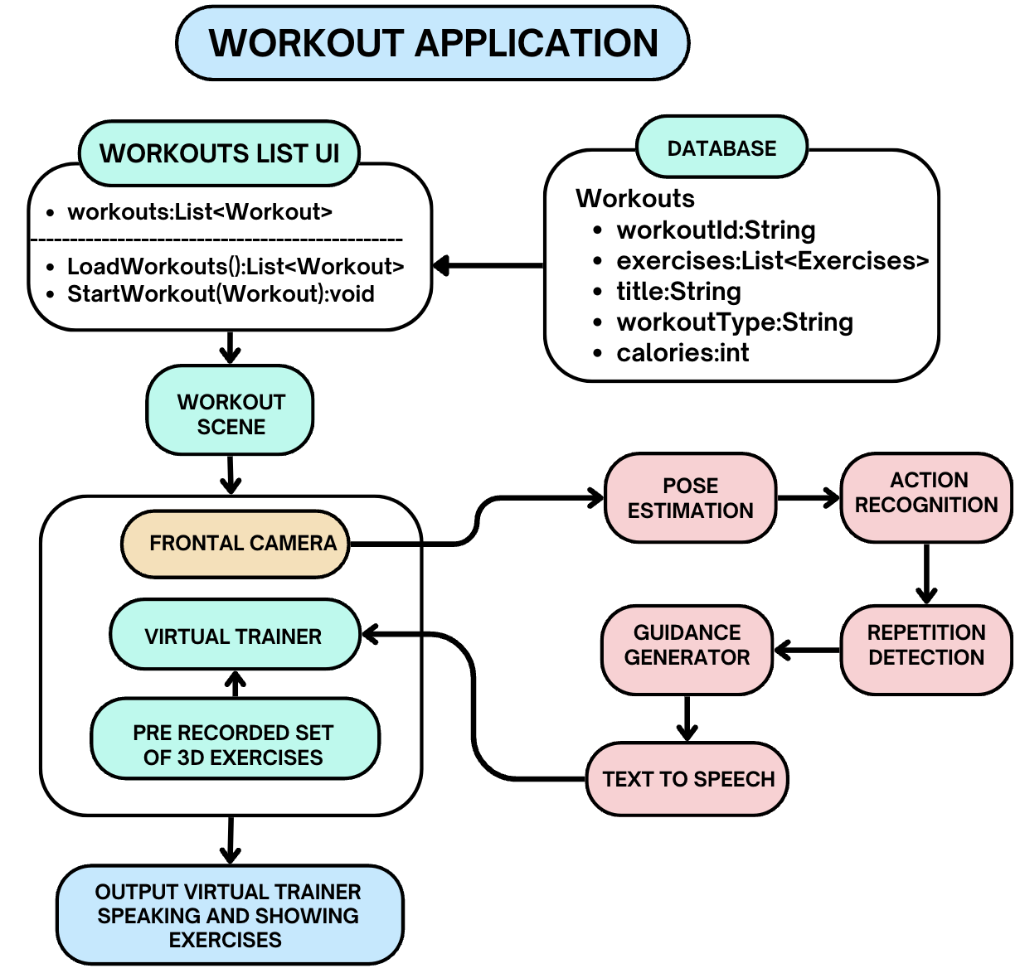
Figure 1. Overall architecture of the proposed workout application and analytical feedback loop.

The first chapter substantiates the relevance of the research topic and formulates the main scientific problem. It shows that the growth of home workouts, remote rehabilitation, and app-guided physical activity has created demand for intelligent systems capable of objective movement assessment outside laboratory settings. Traditional video-guided training is accessible, but it lacks the real-time supervision needed to prevent incorrect movement execution, especially in exercises where trunk posture, joint alignment, and timing are critical.
1.1. Research motivation and technical challenges
The chapter identifies the core technical challenges addressed by the dissertation: accurate 3D pose estimation under uncontrolled mobile conditions; temporal segmentation of continuous motion into repetitions and phases; interpretable biomechanical error detection; creation of a high-quality reference exercise library; real-time synchronization of visual and verbal feedback; and optimization of the analytical pipeline for resource-constrained mobile devices. This chapter also introduces the scientific novelty of the work, which lies in combining pose estimation, temporal movement analysis, IMU-based reference motion capture, a 3D virtual trainer, and mobile on-device feedback into a single end-to-end system.
Chapter 2. CNN-Based Pose Estimation with BlazePose
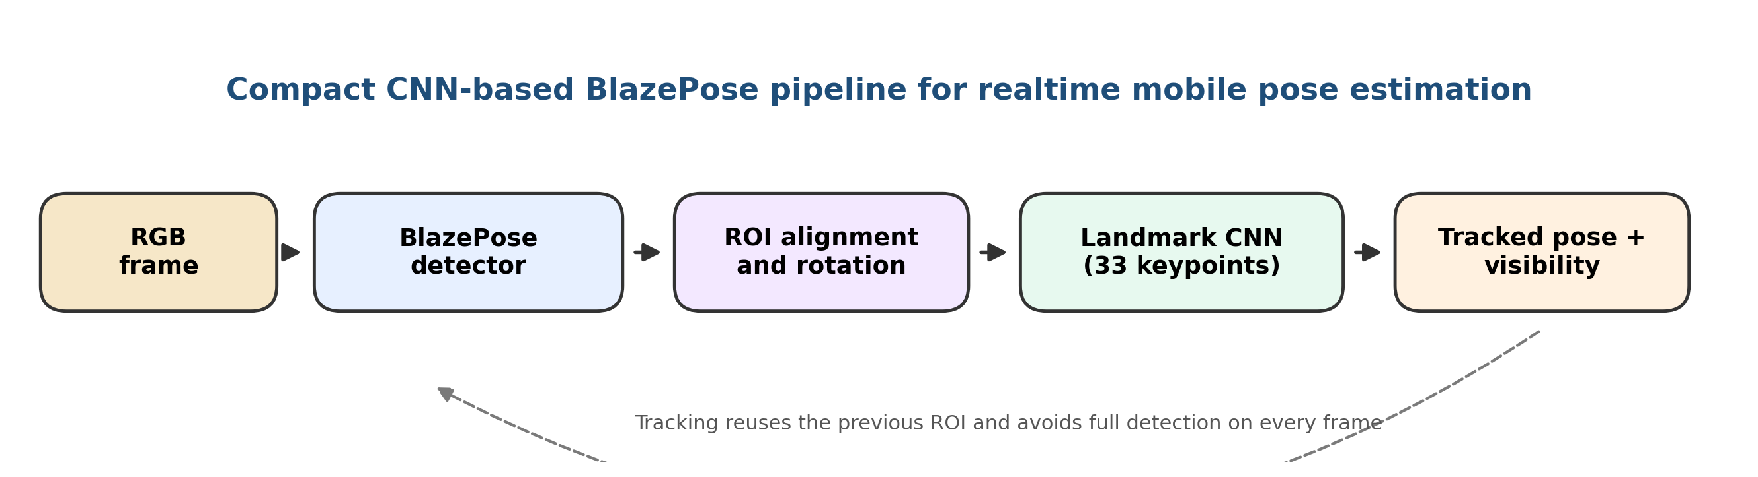
Figure 2.1. Compact BlazePose pipeline for detector-guided mobile landmark regression.
This chapter describes the CNN-based pose-estimation module used as the practical backbone of the proposed workout-analysis system. Instead of a heavy multi-stage transformer pipeline, the mobile implementation relies on BlazePose, a compact detector-tracker architecture designed for realtime inference on smartphones. The method is particularly suitable for fitness analysis because it keeps the subject centered, estimates full-body landmarks, and preserves low latency during continuous exercise execution.
2.1. Core BlazePose Design
BlazePose is designed for real-time, single-person body tracking on mobile devices. Its core idea is to avoid running a heavy body detector on every frame. Instead, the system uses a detector–tracker setup: the detector initializes the person region, and the tracker predicts landmarks and a refined region of interest for subsequent frames. The detector is invoked again only when tracking confidence falls.
The method reconstructs a 33-keypoint body topology that includes the face contour anchors, shoulders, elbows, wrists, hips, knees, ankles, heels, and foot tips. This denser topology is valuable for exercise analysis because it provides more detailed lower-limb and upper-body geometry than a minimal 17-keypoint scheme.
2.2. Key design choices for mobile fitness analysis
Component | Role in the system
Detector + ROI alignment | Normalizes body position, scale, and rotation before landmark inference.
33-keypoint landmark model | Captures limbs, trunk, feet, and face-related anchors required for exercise analysis.
Tracker reuse | Avoids costly redetection on every frame and preserves realtime feedback.
Visibility / presence output | Supports occlusion handling and decides when the system should relocalize the subject.
2.3. Landmark topology and mathematical formulation
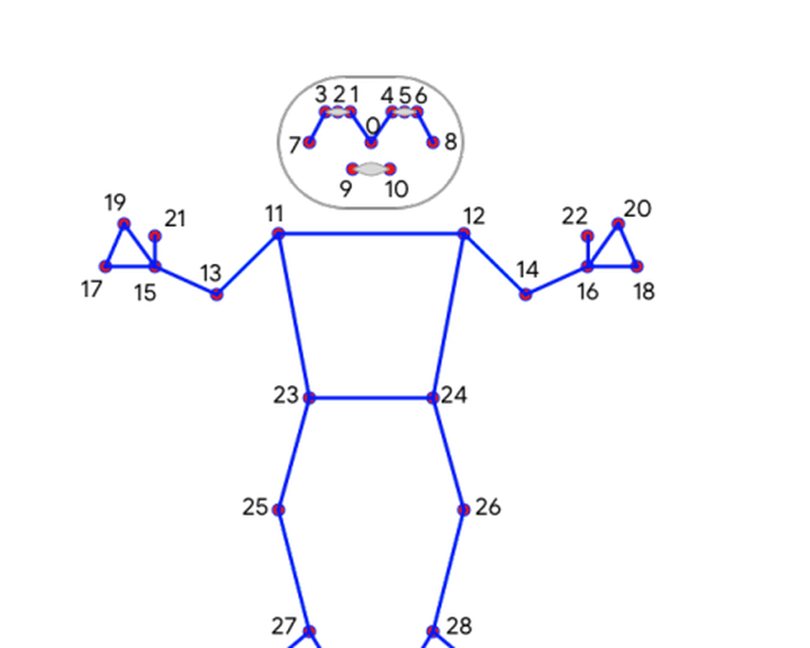  Figure 2.2. BlazePose 33-keypoint topology used for full-body motion capture. | 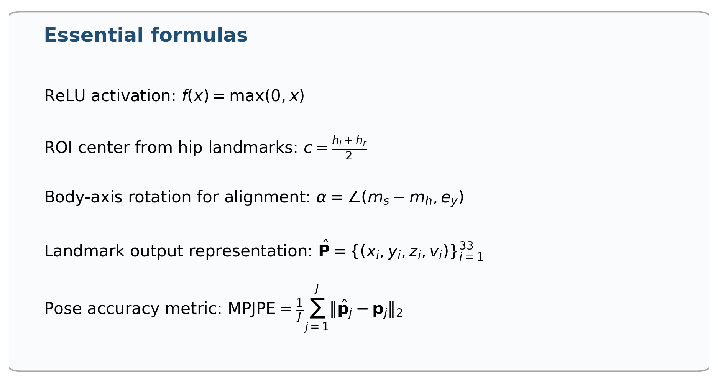
The formulas summarize the operations that make BlazePose efficient in practice: nonlinear feature extraction, body-centered cropping, rotation-normalized tracking, compact landmark regression, and geometric evaluation through MPJPE. In the context of this dissertation, BlazePose is preferable to larger CNN or transformer alternatives because it preserves enough anatomical detail for exercise analysis while still operating at interactive speed on mobile devices. This makes it a practical front-end for repetition detection, rule-based movement assessment, and virtual trainer feedback.
Design characteristic | Why it matters for fitness analysis
Detector–tracker pipeline | Preserves speed by avoiding full detection on every frame.
33-landmark topology | Improves exercise-specific analysis of limbs, trunk, heels, and foot tips.
ROI alignment | Reduces variation in scale and body rotation before landmark prediction.
Heatmap-guided training with regression inference | Balances spatial supervision during learning with low-latency execution at runtime.
Presence / visibility estimation | Helps recover from occlusion and decide when the detector must be re-run.

Figure 3. Thirty-three keypoint body topology used for mobile pose tracking.
Chapter 3. Exercise Recording with Hardware-Based Motion Capture Techniques
The third chapter is devoted to the acquisition of accurate reference motions for the virtual trainer. It compares depth-based, optical marker-based, and inertial motion capture techniques and demonstrates why hardware-based capture remains essential when highly accurate exercise demonstrations are required. While monocular computer vision is practical for online feedback, the trainer’s motion library must be based on reference movements with higher kinematic fidelity.
3.1. Reference motion acquisition
The chapter shows that IMU-based motion capture provides the most balanced solution for the dissertation’s objectives. Optical systems offer the highest precision but are expensive and require a controlled capture volume. Kinect-like systems are accessible but less robust under occlusion. Wearable IMUs, in contrast, provide high portability, stable segment orientation estimates, and a practical workflow for recording exercise libraries that can later be cleaned, retargeted, and mapped onto a 3D avatar. This makes them suitable for generating the virtual trainer’s exercise set.
$$q̂_{t}=f\left(q_{\left(t-1\right)},ω_{t},a_{t},m_{t}\right)$$
In this context, the orientation of a body segment is estimated through sensor fusion of gyroscope, accelerometer, and magnetometer measurements. This enables accurate retargeting of captured motion to the trainer skeleton while preserving temporal consistency.
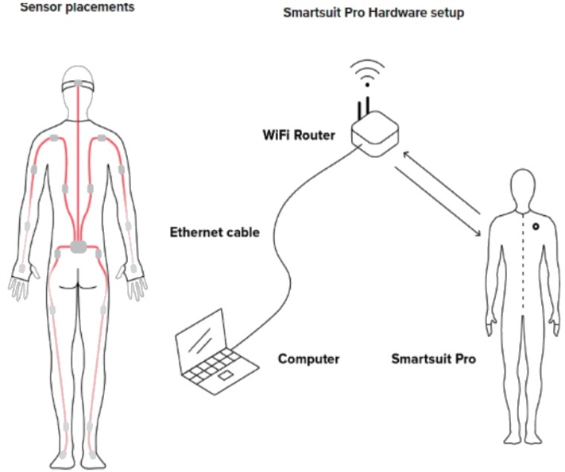
Figure 4. Sensor placement and hardware setup for IMU-based motion capture of reference exercises.
Table 2. Comparative characteristics of the main motion capture technologies
Method | Accuracy | Portability | Operational complexity | Suitability for reference library
Optical marker-based | Very high | Low | High | Excellent but costly
Depth/Kinect-based | Moderate | Moderate | Moderate | Useful for prototyping
IMU-based | High | High | Moderate | Best balance for this research
Chapter 4. Skeleton-Based Human Activity Recognition and Analysis
The fourth chapter introduces the temporal intelligence of the system. It converts sequences of reconstructed landmarks into exercise labels, repetition boundaries, and interpretable corrective feedback. The chapter bridges low-level pose tracking and high-level coaching by treating motion as a structured time-dependent process rather than an isolated set of frames.
4.1. Classification, repetition detection, and corrective guidance
The chapter combines three essential analytical components. First, exercise classification is performed by comparing motion sequences to reference templates. Second, continuous motion is segmented into repetitions using temporal smoothing, thresholding, and finite-state logic. Third, form quality is assessed through geometric measurements such as joint angles and relative distances, which are translated into rule-based feedback messages. This produces repetition-level, exercise-specific, and human-interpretable guidance.
$$DTW\left(X,Y\right)=min_{W}Σd\left(w_{k}\right)$$
$$p̄_{t}=\left(1/N\right)Σ_{\left(i=t-N+1\right)}^{t}p_{i}$$
$$θ=arccos\left(\left(u·v\right)/\left(\left|\left|u\right|\right|\left|\left|v\right|\right|\right)\right)$$
Dynamic Time Warping aligns exercise sequences performed at different speeds; moving-average smoothing reduces landmark noise; and joint-angle computation makes it possible to evaluate squat depth, trunk inclination, knee flexion, and similar biomechanical characteristics. The result is a rule-based guidance mechanism that can produce targeted messages such as adjusting depth, improving symmetry, or correcting excessive forward lean.
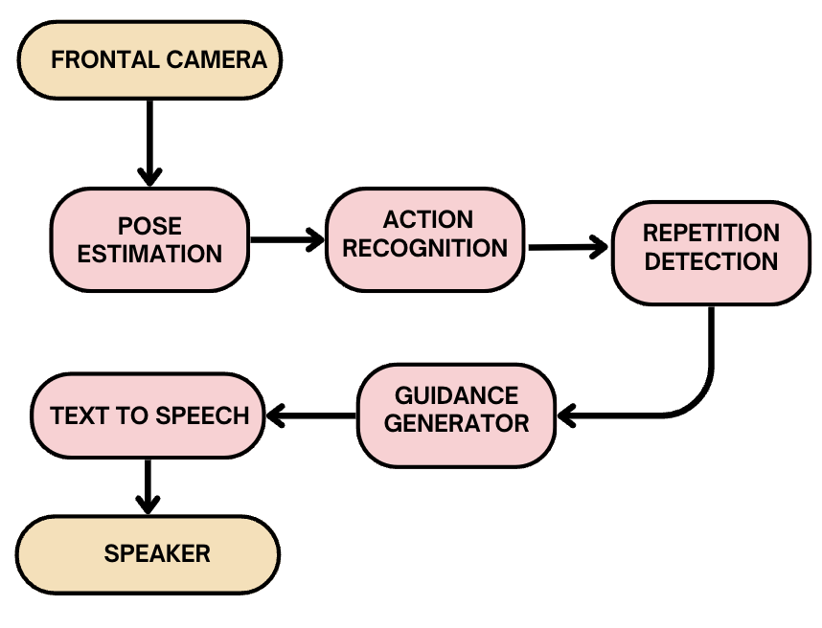
Figure 5. Core analytical feedback loop: pose estimation, action recognition, repetition detection, guidance generation, and text-to-speech.
Chapter 5. Implementation
The fifth chapter describes the practical realization of the proposed system as a mobile application. Flutter and Dart are used for the mobile interface and application logic, Unity is used for the 3D trainer environment, MediaPipe is used for real-time landmark extraction, and text-to-speech modules provide verbal feedback. The implementation chapter demonstrates how the theoretical pipeline is translated into a working interactive product.
5.1. System integration and mobile deployment
The implementation is centered on three essential subsystems: the application layer, the analytical layer, and the interactive feedback layer. The application layer manages workouts, user interaction, and content delivery. The analytical layer processes camera input, reconstructs landmarks, classifies motion, and evaluates posture. The feedback layer synchronizes the virtual trainer, generated textual guidance, and synthesized speech. A key practical contribution of this chapter is the integration of Flutter and Unity through platform channels, making it possible to exchange data between the mobile interface and the 3D training scene in real time.
Chapter 6. Experimental Results and Evaluation
The sixth chapter provides quantitative validation of the developed system. It evaluates pose estimation accuracy, segmentation quality, error-detection reliability, system responsiveness, fidelity of IMU-based trainer motions, and user-level performance changes over time. The reported results confirm that the system achieves real-time operation while maintaining sufficient accuracy for practical biomechanical guidance.
6.1. Main quantitative findings
The central metric for 3D pose reconstruction is the Mean Per Joint Position Error, which measures the average Euclidean distance between predicted and reference joints. The chapter further evaluates temporal overlap for repetition segmentation, precision and recall for posture-error detection, latency of the virtual trainer and speech pipeline, and kinematic fidelity of IMU-based motion capture.
$$MPJPE=\left(1/J\right)Σ{\left|\left|p̂_{j}-p_{j}\right|\right|}^{2}$$
Table 3. Summary of the principal experimental results
Module / scenario | Metric | Result
3D pose estimation - controlled conditions | MPJPE | 28.5 ± 4.3 mm
3D pose estimation - mobile with partial occlusion | MPJPE | 36.8 ± 5.7 mm
3D pose estimation - low illumination | MPJPE | 42.1 ± 6.2 mm
Realtime inference | Per-frame latency | 42 ± 8 ms (>23 fps)
Repetition segmentation | Temporal accuracy | 94.7%
Squat error detection | Precision / recall | 0.91 / 0.89
Yoga error detection | Precision / recall | 0.88 / 0.85
Virtual trainer rendering | Update latency | 58 ms
Speech quality | Mean opinion score | 4.3 / 5
IMU motion capture | Orientation error | 2.9°
IMU motion capture | Joint-angle RMSE | 4.7°
User study - amateur cohort | Reduction in deviation events | 21.3%
The experimental results show that the proposed environment is not merely a conceptual prototype. It operates within interactive latency limits, maintains acceptable reconstruction accuracy in realistic mobile settings, and produces feedback that users perceive as understandable and helpful. The longitudinal study further indicates a measurable reduction in technique deviations, suggesting that the system can contribute to safer and more consistent exercise execution.
Chapter 7. Conclusions and Future Research Directions
The final chapter summarizes the scientific and practical contributions of the dissertation. The work resulted in a unified intelligent environment that combines monocular 3D pose estimation, temporal exercise analysis, biomechanical error reasoning, IMU-based motion capture, a virtual trainer, and multimodal guidance into a deployable mobile system.
7.1. Generalized conclusions
The dissertation demonstrates that mobile AI systems can provide sufficiently accurate and responsive biomechanical coaching without requiring specialized laboratory infrastructure. At the same time, the chapter acknowledges several limitations: monocular depth ambiguity, dependence on reference templates and predefined thresholds, limited validation scale, and restricted exercise coverage. Future work is therefore directed toward multimodal sensor fusion, adaptive personalization, uncertainty-aware evaluation, expansion of exercise libraries, and longer clinical and longitudinal studies.

Essential formulas used in the research
For convenience, the principal mathematical expressions employed across the dissertation are summarized below.
Table 4. Core formulas and their role in the dissertation
Formula | Role | Used in chapter
$$PE\left(pos,2i\right)=sin\left(pos/{10000}^{\left(2i/d\right)}\right);$$  $$PE\left(pos,2i+1\right)=cos\left(pos/{10000}^{\left(2i/d\right)}\right)$$ | Positional encoding for transformer-based temporal modeling | 2
$$M\left(β,θ,γ\right)$$ | Parametric human body representation | 2
$$E\left(β,θ,γ\right)=E_{J}+λ_{θ}E_{θ}+λ_{a}E_{a}+λ_{s}pE_{s}p+λ_{β}E_{β}$$ | Regularized SMPL fitting objective | 2
$$q̂_{t}=f\left(q_{\left(t-1\right)},ω_{t},a_{t},m_{t}\right)$$ | Sensor-fusion orientation estimate for IMU-based tracking | 3
$$DTW\left(X,Y\right)=min_{W}Σd\left(w_{k}\right)$$ | Temporal alignment for exercise classification | 4
$$p̄_{t}=\left(1/N\right)Σ_{\left(i=t-N+1\right)}^{t}p_{i}$$ | Noise reduction in repetition detection | 4
$$θ=arccos\left(\left(u·v\right)/\left(\left|\left|u\right|\right|\left|\left|v\right|\right|\right)\right)$$ | Joint-angle evaluation for rule-based guidance | 4
$$MPJPE=\left(1/J\right)Σ{\left|\left|p̂_{j}-p_{j}\right|\right|}^{2}$$ | Quantitative evaluation of 3D pose accuracy | 6
In summary, the dissertation presents a logically connected research trajectory: from problem formulation and theoretical foundations to motion capture, activity analysis, software implementation, and experimental validation. Its main contribution is the development of an end-to-end intelligent environment that transforms consumer mobile devices into practical tools for biomechanical monitoring and interactive exercise coaching.

Main results of the dissertation

The dissertation resulted in the design and implementation of an intelligent AI-based environment for automated analysis of physical performance and human motor behavior. Its principal contribution is the construction of a unified mobile framework that transforms monocular visual input into 3-D movement representation, repetition-aware temporal analysis, interpretable biomechanical assessment, and real-time multimodal coaching.
- Achieving real-time, noise-robust 3-D pose estimation on smartphones
One of the main results of the dissertation is the demonstration that smartphone-class devices can support real-time pose estimation suitable for fitness and rehabilitation analysis. The proposed pipeline remains functional under practical disturbances such as lighting variation, background clutter, partial occlusion, and body-scale differences. This result is important because it shifts posture analysis from controlled laboratory settings into accessible home environments, where inexpensive and portable supervision is most needed.
$$MPJPE=\left(1/J\right)Σ\left[j=1..J\right]{\left|\left|p̂_{j}-p_{j}\right|\right|}^{2}$$
Using the mean per-joint position error as the main reconstruction criterion, the system attains 28.5 mm error in controlled conditions, 36.8 mm in partially occluded mobile conditions, and 42.1 mm in low-light scenes. The runtime of 42 ± 8 ms per frame, corresponding to more than 23 fps, confirms that the solution is fast enough for interactive mobile use.
- Segmenting continuous exercise streams into meaningful repetitions
A second dissertation result is the development of a temporal analysis mechanism that does not treat exercise as an undifferentiated sequence. Instead, the motion stream is segmented into repetitions and local movement phases, which makes it possible to evaluate technique repetition by repetition. This is essential for practical coaching because errors frequently emerge only in later repetitions due to fatigue or reduced control.
$$DTW\left(X,Y\right)=min_{W}Σ\left[k=1..K\right]d\left(w_{k}\right)$$
$$p̄_{t}=\left(1/N\right)Σ\left[i=t-N+1..t\right]p_{i}$$
The combination of sequence alignment and temporal smoothing makes the analysis robust to different execution speeds and signal noise. Experimentally, the repetition segmentation module reaches 94.7% accuracy, confirming that the system can reliably identify the internal structure of exercise performance.
- Formalizing interpretable biomechanical error detection rather than black-box scoring
A central scientific result of the dissertation is the transition from simple action recognition to interpretable movement-quality evaluation. The system computes geometric relations between body segments and compares them with exercise-specific constraints, thereby producing explicit feedback about where the movement is incorrect. This improves practical usefulness because the user receives correction cues tied to posture mechanics rather than an opaque class label.
$$θ=arccos\left(\left(u·v\right)/\left(\left|\left|u\right|\right|\left|\left|v\right|\right|\right)\right)$$
$$θ_{m}in≤θ≤θ_{m}ax$$
These relations allow the platform to quantify squat depth, trunk inclination, knee alignment, and similar technique-sensitive features. For squat deviations, the error-detection module achieves precision and recall values of 0.91 and 0.89, which shows that interpretable joint-angle reasoning can operate with high reliability in real time.
- Constructing a motion-captured 3-D virtual trainer for reference-quality demonstration
The dissertation also delivers a high-fidelity reference-motion subsystem based on inertial measurement units. Correctly executed exercises are captured from a performer, cleaned, retargeted to a humanoid avatar, and then reused as a standard for demonstration and comparison. This result is methodologically important because it grounds the virtual trainer in recorded human motion instead of handcrafted animation approximations.
$$q̂_{t}=f\left(q_{\left(t-1\right)},ω_{t},a_{t},m_{t}\right)$$
Here the orientation of a body segment is updated from gyroscope, accelerometer, and magnetometer information. The resulting IMU-based motion library achieves approximately 2.9° orientation error and 4.7° joint-angle RMSE, which is sufficiently accurate for visually convincing demonstration and biomechanical reference.
- Integrating corrective analytics, 3-D visualization, and speech feedback into a single mobile environment
Another major result is the engineering integration of the full feedback loop. The dissertation does not stop at measurement; it connects pose estimation, sequence analysis, rule-based reasoning, 3-D trainer visualization, and voice output in one user-facing application. This demonstrates that analytical intelligence and interactive coaching can be combined within a standalone system rather than existing as isolated modules.
$$E\left(β,θ,γ\right)=E_{J}+λ_{θ}E_{θ}+λ_{a}E_{a}+λ_{s}pE_{s}p+λ_{β}E_{β}$$
This compact objective reflects the broader principle used throughout the dissertation: motion estimates must satisfy both observation consistency and biomechanical plausibility. The integrated trainer responds with end-to-end feedback latency below 200 ms, while the speech subsystem reaches a Mean Opinion Score of 4.3/5, indicating that the multimodal interaction remains responsive and usable in practice.
- Demonstrating measurable improvement in user movement quality over time
The final important result is experimental confirmation that the system is not only technically functional but also behaviorally useful. In longitudinal use, participants showed a 21.3% reduction in biomechanical deviation events, which indicates that repeated exposure to the corrective loop improves technique quality. This transforms the platform from a passive monitoring tool into an active guidance system capable of supporting learning, injury-risk reduction, and more consistent training behavior.
Result area | Main outcome | Quantitative evidence
3-D pose estimation | Noise-robust smartphone reconstruction | 28.5–42.1 mm MPJPE
Temporal segmentation | Reliable repetition extraction | 94.7% accuracy
Biomechanical feedback | Interpretable error detection | 0.91 / 0.89 precision-recall
Reference motion capture | High-fidelity trainer animation | 2.9° and 4.7° error
Interactive deployment | Real-time multimodal coaching | >23 fps; <200 ms latency
User impact | Improved movement quality | 21.3% deviation reduction
Taken together, these results show that the dissertation contributes not only separate algorithms but an end-to-end methodology for converting raw visual observations into actionable movement-quality assessment on mobile hardware. The work therefore provides both a scientific framework for AI-driven biomechanical analysis and a practical foundation for future fitness, rehabilitation, and remote coaching systems.

LIST OF PUBLICATIONS ON THE TOPIC OF THE THESIS
- M. Aslanyan, “Development of Intelligent Workout Environment for VR Devices” 2024 IEEE Global Engineering Education Conference (EDUCON), Kos Island, Greece, 2024, pp. 1-5
- M. Aslanyan, “On Mobile Pose Estimation and Action Recognition Design and Implementation.” Pattern Recognition and Image Analysis, 2024, pp. 126–136
- M. Aslanyan, “Comparative Evaluation of Inertial Measurement Unit Versus Vision Based Motion Capture” Pattern Recognition and Image Analysis, 2026
- M. Aslanyan “On Mobile Pose Estimation Design and Implementation.” CSIT Conference, 2023

ՄԻՆԱՍ ԱՍԼԱՆՅԱՆ

Սեղմագիր
ՄԱՐԴՈՒ ՇԱՐԺՈՂԱԿԱՆ ՎԱՐՔԱԳԾԻ ԱՎՏՈՄԱՏԱՑՎԱԾ
ԲԱՆԱԿԱՆԱՅԻՆ ՄԻՋԱՎԱՅՐԻ ՄՇԱԿՈՒՄ

Հետազոտության համառոտ ամփոփում
Այս հետազոտությունը նվիրված է սպորտային և ֆիթնես գործունեության վերլուծության համար նախատեսված բարձր տեխնոլոգիական ինտելեկտուալ միջավայրի մշակմանը: Ժամանակակից աշխարհում տնային պայմաններում մարզվելու պահանջարկի աճին զուգահեռ՝ առաջանում է վնասվածքների մեծ ռիսկ՝ մասնագիտական վերահսկողության բացակայության պատճառով: Աշխատանքը լուծում է այս խնդիրը՝ միավորելով համակարգչային տեսողության (Computer Vision), մեքենայական ուսուցման (Machine Learning) և բիոմեխանիկական վերլուծության մեթոդները:
Հետազոտության ընթացքում մշակվել է համակարգ, որն ընդունակ է սովորական սմարթֆոնի տեսախցիկի միջոցով իրական ժամանակում վերակառուցել մարդու մարմնի 3D մոդելը (Pose Estimation): Ի տարբերություն ավանդական մեթոդների, որոնք պահանջում են թանկարժեք լաբորատոր սարքավորումներ կամ բազմաթիվ տեսախցիկներ, այս աշխատանքում կիրառվել են օպտիմալացված նեյրոնային ցանցեր, որոնք ապահովում են բարձր ճշգրտություն նույնիսկ մեկ տեսախցիկի պարագայում: Համակարգը ոչ միայն հետևում է շարժմանը, այլև վերլուծում է վարժության տեխնիկական ճշտությունը՝ համեմատելով այն էտալոնային (MoCap) տվյալների հետ և տրամադրելով ակնթարթային հետադարձ կապ:

Աշխատանքի նպատակը
Հիմնական նպատակն է ստեղծել ԱԲ-ի վրա հիմնված համապարփակ և մատչելի բջջային էկոհամակարգ, որը կծառայի որպես «վիրտուալ մարզիչ»: Այն պետք է ապահովի շարժումների ճշգրիտ ճանաչում, վարժությունների ավտոմատ հաշվարկ և սխալների հայտնաբերում՝ բարձրացնելով մարզումների արդյունավետությունն ու անվտանգությունը:

Գործնական նշանակությունը
Աշխատանքն ունի ուղղակի կիրառական նշանակություն առողջապահության, պրոֆեսիոնալ սպորտի և վերականգնողական բժշկության ոլորտներում: Մշակված ալգորիթմները թույլ են տալիս ստեղծել հավելվածներ, որոնք հասանելի են լայն զանգվածներին՝ վերացնելով թանկարժեք սենսորների կամ մարզիչների անհրաժեշտությունը տեխնիկապես բարդ վարժությունների կատարման ժամանակ:

Իրականացման արդյունքները
Համակարգը հաջողությամբ ինտեգրվել է Flutter և Unity հարթակներում՝ ապահովելով խաչաձև հարթակային (iOS/Android) հասանելիություն: Իրականացվել է նաև մոդելների քվանտացում (quantization), ինչը թույլ է տվել աշխատեցնել բարդ նեյրոնային ցանցերը սմարթֆոնների պրոցեսորների (NPU/GPU) վրա՝ առանց սարքի գերտաքացման:

Գլուխների համառոտագիր
• Գլուխ 1. Խնդրի դրվածքը և ոլորտի ժամանակակից լուծումների վերլուծությունը:
• Գլուխ 2. Միակնյա տեսախցիկով 3D դիրքի գնահատման նորարարական մեթոդների մշակումը:
• Գլուխ 3. Շարժման գրանցումը (MoCap) և տվյալների բազաների ստեղծումը IMU սենսորների միջոցով:
• Գլուխ 4. Գործողությունների ճանաչման և կրկնությունների հաշվարկման ալգորիթմների նախագծումը:
• Գլուխ 5. Ծրագրային ճարտարապետության իրականացումը և օպտիմալացման ռազմավարությունները:
• Գլուխ 6. Էմպիրիկ հետազոտությունների և թեստավորման արդյունքների վերլուծությունը:
• Գլուխ 7. Եզրակացություններ և հետագա զարգացման ուղիները:

Հիմնական արդյունքներ

Մշակվել է սմարթֆոնների համար իրական ժամանակում աշխատող, աղմուկների և խանգարումների նկատմամբ կայուն 3D դիրքի գնահատման համակարգ։

Առաջարկվել է վարժությունների հոսքային կատարման բաժանում առանձին կրկնությունների և փուլերի՝ ավելի ճշգրիտ ժամանակային վերլուծության համար։

Մշակվել է մեկնաբանելի բիոմեխանիկական սխալների հայտնաբերման մեխանիզմ՝ հոդային անկյունների և կանոնահեն գնահատման հիման վրա։

Ստեղծվել է IMU սենսորների վրա հիմնված շարժումների գրանցման և 3D վիրտուալ մարզչի անիմացիոն վերարտադրման ենթահամակարգ։

Իրականացվել է մեկ միասնական բջջային միջավայր, որը միավորում է դիրքի գնահատումը, շարժման վերլուծությունը, 3D վիզուալիզացիան և ձայնային հետադարձ կապը։

Փորձարարական արդյունքներով հիմնավորվել է համակարգի գործնական արդյունավետությունը՝ շարժումների որակի բարելավման և սխալների նվազեցման տեսանկյունից։

МИНАС АСЛАНЯН
ИНТЕЛЛЕКТУАЛЬНАЯ СРЕДА НА ОСНОВЕ ИИ ДЛЯ АВТОМАТИЗИРОВАННОГО АНАЛИЗА
ФИЗИЧЕСКОЙ ДЕЯТЕЛЬНОСТИ И ДВИГАТЕЛЬНОГО ПОВЕДЕНИЯ ЧЕЛОВЕКА

Актуальность темы и краткое резюме
Актуальность работы обусловлена пересечением повсеместного распространения мобильных технологий, искусственного интеллекта и необходимости безопасных и эффективных домашних тренировок. Традиционные видеотренировки ограничены: монокулярные камеры не позволяют точно воспринимать 3D-конфигурации суставов, а отсутствие экспертного контроля ведет к сохранению неправильных паттернов движения (например, сгибание поясницы в становой тяге), что повышает риск травм.
Данное исследование решает эти проблемы путем создания системы, реконструирующей 3D-скелетную кинематику по монокулярному видео в реальном времени. Интеграция сверточных нейронных сетей с геометрическими моделями позволяет мобильным устройствам достигать высокой точности в обнаружении отклонений от идеальных траекторий суставов.

Цель и задачи исследования
Основная цель — создание комплексной мобильной системы, которая реконструирует 3D-позы пользователя в реальном времени, анализирует биомеханику упражнений, обнаруживает ошибки и предоставляет интерактивную обратную связь.
Ключевые задачи:
• Разработка мобильного приложения на базе фронтальной камеры для захвата движений.
• Интеграция оптимизированных 3D-моделей оценки поз (квантованные CNN, легковесные геометрические модули).
• Реализация временного анализа движений (DTW-автокорреляция) для обнаружения ошибок.
• Интеграция интерактивного 3D-виртуального тренера на основе MoCap-данных.
• Оптимизация производительности для достижения задержки менее 100 мс на кадр.

Научная новизна
• Разработана новая метрика биомеханических ошибок («Error Rate»), объединяющая временное выравнивание (через DTW) с анализом угловых отклонений суставов.
• Предложена стратегия сжатия и прунинга нейронных сетей, адаптированная для мобильных CPU/NPU, обеспечивающая частоту кадров менее 100 мс.
• Создан интерактивный мультимодальный цикл обратной связи, объединяющий 3D-аватара (синтезированного из IMU-данных) и контекстно-зависимую систему синтеза речи (TTS).
• Продемонстрирована устойчивость системы к неконтролируемым домашним условиям (освещение, фон) благодаря этапу семантической сегментации.

Практическая значимость
• Повышение безопасности: Снижение риска травм при самостоятельных тренировках.
• Доступность: Устранение необходимости в дорогостоящем оборудовании.
• Персонализация: Адаптация инструкций виртуального тренера под прогресс пользователя.
• Экономическая эффективность: Использование существующих мощностей смартфонов.
• Масштабируемость: Широкая совместимость с потребительскими устройствами.

Методы исследования и реализация
Исследование следует смешанному инженерному циклу: от анализа литературы до создания двухэтапного конвейера зрения (обнаружение 2D-ключевых точек и их «подъем» в 3D). Для генерации эталонных движений использовался костюм с 19 IMU-сенсорами (Rokoko Smartsuit Pro). Приложение реализовано в среде Flutter + Unity, где Unity отвечает за рендеринг 3D-тренера, а Flutter — за логику и интерфейс. Распознавание активности сочетает DTW и k-NN, а подсчет повторений реализован через отказоустойчивый алгоритм Zero-Crossing.

Краткое содержание глав
• Глава 1: Введение и обоснование актуальности.
• Глава 2: Теоретические основы 3D-оценки поз по монокулярному видео (обзор CNN, трансформеров).
• Глава 3: Технологии захвата движений и создание базы эталонов с использованием IMU-сенсоров.
• Глава 4: Распознавание действий на основе скелетных данных и генерация вербальной обратной связи.
• Глава 5: Архитектура ПО и стратегии оптимизации под мобильные платформы.
• Глава 6: Результаты экспериментов и пользовательские тесты.
• Глава 7: Заключение и выводы.

Основные результаты работы
- Разработана система оценки 3D-позы в реальном времени для смартфонов, устойчивая к шумам и внешним помехам.
- Предложен метод разбиения непрерывного выполнения упражнений на отдельные повторения и фазы для более точного временного анализа.
- Разработан интерпретируемый механизм обнаружения биомеханических ошибок на основе суставных углов и правил оценки.
- Создана подсистема захвата движений на основе IMU-сенсоров и анимационного воспроизведения 3D виртуального тренера.
- Реализована единая мобильная среда, объединяющая оценку позы, анализ движений, 3D-визуализацию и голосовую обратную связь.
- Экспериментально подтверждена практическая эффективность системы с точки зрения повышения качества движений и снижения числа ошибок.

